Prepared By:
Data Informatics & Innovation Division (DIID)
Ministry of Statistics and Programme Implementation (MoSPI),
Government of India

Copyright
© Data Informatics and Innovation Division, MoSPI, Govt. of India, 2025 – All Rights Reserved.
Disclaimer
No part of this material may be reproduced in any form without the written permission of the copyright owner.
Document history
Status | Version | Author | Change description | Date
First Draft | V1.0 | DIID | FRS regarding NSS 75th Round | 18.12.25
Second Draft | V1.1 | DIID | Incorporation of Comments and Feedback provided by DIID Officials on certain sections. | 06.01.26

Table of Contents
1 Introduction 5
1.1 Overview of National Sample Survey 75th Round 5
1.2 Purpose of this Document 5
2 Scope 6
3 Functional Requirements 7
3.1 Data Acquisition Module 7
3.2 Data Modelling 25
3.3 Data Processing Module (ETL) 27
4 User Interface Mockup / Wireframes 27
4.1 Table 27
4.2 Chart 30
4.3 API 33
4.4 Metadata 34
5 Non- Functional Requirement 34
5.1 Scalability & Load Handling 35
5.2 Performance Optimization & Testing 35
5.3 Reliability & Data Protection 35
5.4 Usability & Compliance 35
6 Appendices 36
6.1 Glossary of Terms 36
6.2 Abbreviations 36

Introduction
The Ministry of Statistics & Programme Implementation (MoSPI) is mandated with the collection, processing, compilation, and dissemination of official statistical data in the country. While various Divisions within MoSPI are tasked with data collection/ acquisition, its cleaning, validation, processing and compilation of results and publication based on the acquired data, the Data Informatics & Innovation Division (DIID), an attached office of MoSPI, is primarily tasked with management and dissemination of compiled indicators and publications through its website, the eSankhyiki portal, and the Ministry’s Microdata portal.

Overview of National Sample Survey 75th Round
The National Sample Survey (NSS) 75th Round is a nationwide household survey conducted by the National Statistical Office (NSO) under the Ministry of Statistics and Programme Implementation (MoSPI). The 75th Round of the National Sample Survey (NSS) was conducted as a nationwide socio-economic sample survey over a period of one year from July 2017 to June 2018. This round collected data on topics such as social consumption (including education and health) using scientific sampling methods across all States and Union Territories of India.The survey provides statistically robust estimates on key socio-economic indicators based on the specific subject matter covered under the 75th Round, with coverage across rural and urban areas of India. The survey (Health and Education) follows established NSS sampling design, concepts, definitions, and estimation methodologies to ensure national and sub-national representativeness.
The data generated through the NSS 75th Round is a critical input for evidence-based policymaking, academic research, and public dissemination, and forms part of India’s official statistical system.

Purpose of this Document
The purpose of this Functional Requirements Specification (FRS) document is to define the functional and non-functional requirements for onboarding NSS 75th Round data onto the eSankhyiki Portal of MoSPI. The document serves as a common reference for stakeholders, system architects, developers, and testers to clearly understand the scope, data flow, system behavior, and quality expectations.
This document primarily outlines the process for enhancing data management and dissemination of NSS 75th Round data (Health and Education), transitioning from the existing dissemination mechanism (primarily MS Excel-based tables and reports) to structured onboarding within the Macro Indicators module of the eSankhyiki portal.

Scope
The e-Sankhyiki is a portal developed by the Ministry of Statistics and Programme Implementation (MoSPI) to provide real-time access to official statistics for planners, policymakers, researchers, and the public. The Central Data Repository is integrated within eSankhyiki, acting as a comprehensive database that stores and organizes statistical data for ease of access and analysis.
The Central Data Repository (CDR)/ eSankhyiki has been envisaged with the objective of establishing databases for key macro-indicators, CPI, NAS, IIP, PLFS, ASI, recent survey reports etc. It is a single point of access to all publicly available datasets of the ministry designed to make the datasets easy to find, download and share.
CDR has been developed with the aim to establish a data pipeline for acquiring, processing, and storing official statistical data in a centralized warehouse. The pipeline follows an ETL (Extract, Transform, Load) process, ensuring data acquisition, cleaning, transformation, and standardized storage. Data dissemination occurs through eSankhyiki portal via Table, Chart, API & Metadata.
The different stages within a Data Pipeline are depicted in the following figure:
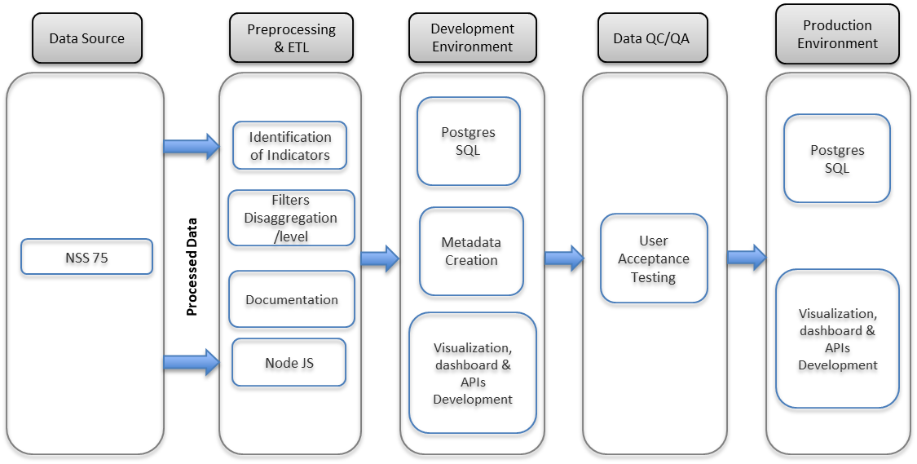
Figure 1: Stages of onboarding NSS 75th Round on e-Sankhyiki Portal

Functional Requirements

Data Acquisition Module
The Data Acquisition Module is designed to facilitate the seamless acquisition and onboarding of data from National Sample Survey Office (NSSO). Steps are as following:
- The Household Survey Division (HSD) sends the report and tables for uploading on the website which are then shared with the development team of e-Sankhyiki after consulting with the concerned division of MoSPI.
- The Excel files contain datasheets on health and education in India, presenting indicator-wise data at the State and Union Territory level.
- NSS 75th Round data source details in Tabular format for Health in India:
  - States/UT’s Data
State Code | Description
1 | Andhra Pradesh
2 | Arunachal Pradesh
3 | Assam
4 | Bihar
5 | Chhattisgarh
6 | Delhi
7 | Goa
8 | Gujarat
9 | Haryana
10 | Himachal Pradesh
11 | Jharkhand
12 | Karnataka
13 | Kerala
14 | Madhya Pradesh
15 | Maharashtra
16 | Manipur
17 | Meghalaya
18 | Mizoram
19 | Nagaland
20 | Odisha
21 | Punjab
22 | Rajasthan
23 | Sikkim
24 | Tamil Nadu
25 | Telangana
26 | Tripura
27 | Uttar Pradesh
28 | Uttarakhand
29 | West Bengal
30 | A & N Islands
31 | Chandigarh
32 | Dadra & Nagar Haveli and Daman & Diu
33 | Jammu & Kashmir
34 | Ladakh
35 | Lakshadweep
36 | Puducherry
37 | All-India

  - For all the States/ UTs Survey names and code are as follows (as per the NSS 75th Round files downloaded from MoSPI website):
Survey Code | Survey name
1 | Health In India
2 | Education
  - For all the States/ UTs Indicator names and code with survey code mapping is as follows (as per the NSS 75th Round files downloaded from MoSPI website):
Mapping Table for Health in India:
Survey Code | Indicator Code | List of Indicators
1 |  | Hospitalisation cases (excluding childbirth) per 100,000 persons
1 |  | Hospitalisation cases (excluding childbirth) per 100,000 persons
1 |  | Hospitalisation cases (excluding childbirth) per 100,000 persons
1 |  | Percentage distribution of hospitalised cases (excluding childbirth):
1 |  | Percentage distribution of hospitalised cases (excluding childbirth):
1 |  | Percentage distribution of hospitalised cases (excluding childbirth):
1 |  | Percentage distribution of hospitalised cases (excluding childbirth):
1 |  | Percentage distribution of hospitalised cases (excluding childbirth):
1 |  | Percentage distribution of hospitalised cases (excluding childbirth):
1 |  | Average medical expenditure for treatment per hospitalisation case (excluding childbirth) as inpatient
1 |  | Average medical expenditure for treatment per hospitalisation case (excluding childbirth) as inpatient
1 |  | Average medical expenditure for treatment per hospitalisation case (excluding childbirth) as inpatient
1 |  | Average medical expenditure on account of hospitalisation per hospitalisation case (excluding childbirth)
1 |  | Average medical expenditure on account of hospitalisation per hospitalisation case (excluding childbirth)
1 |  | Average medical expenditure (Rs.) per hospitalisation case (excluding childbirth):
1 |  | Average out-of-pocket medical expenditure (OOPME)for treatment per hospitalisation case (excluding childbirth):
1 |  | Average out-of-pocket medical expenditure (OOPME)for treatment per hospitalisation case (excluding childbirth):  as inpatient
1 |  | Number per 1000 persons reporting ailments (PAP) during last 15 days by gender and age-group
1 |  | Number of ailments reported Per 100000 persons during the last 15 days for each ailment type
1 |  | Number of ailments of each broad ailment category reported per 100000 persons during the last 15 days by age-group
1 |  | Percentage distribution of spells of ailment over broad ailment categories for different age groups during last 15 days
1 |  | Number of persons per 1,00,000 reporting onset of ailments during last 15 days and average duration of ailment by gender and broad ailment category separately for chronic and non-chronic ailments
1 |  | Average medical expenditure and non-medical expenditure (in Rs.) for treatment per ailing person during a period of last 15 days for each state/UT
1 |  | Average medical expenditure and non-medical expenditure for treatment per treated spell of ailment during a period of last 15 days for each quintile class of household expenditure
1 |  | Average medical expenditure for (non-hospitalised) treatment per treated spell of ailment during last 15 days by level of care for each broad nature of ailment
1 |  | Average medical expenditure for (non-hospitalised) treatment per treated spell of ailment during last 15 days by level of care for each quintile class of household expenditure
1 |  | Average medical expenditure for (non-hospitalised) treatments per spell of treated ailment during last 15 days by nature of treatment, for each State/UT
1 |  | Average medical expenditure for (non-hospitalised) treatments per treated spell of ailment during last 15 days by nature of treatment, for each quintile class of household expenditure
1 |  | Average out-of-pocket medical expenditure for (non-hospitalised) treatment per treated spell of ailment during last 15 days by level of care for each state/UT
1 |  | Percentage distribution of aged persons by state of economic independence for each State/UT
1 |  | Percentage distribution of aged persons of each age-group by state of physical mobility
1 |  | Percentage distribution of aged persons of each State/UT by state of physical mobility
1 |  | Percentage of children (0 – 5 years) receiving any type of immunisation and average expenditure incurred on immunisation during last 365 days for each State/UT
1 |  | Percentage distribution of cases of hospitalisation for childbirth by type of medical institution for each State/UT
1 |  | Percentage distribution of cases of hospitalisation for childbirth by type of medical institution for each quintile class of household expenditure
1 |  | Percentage distribution of cases of hospitalisation for childbirth by type of medical institution for each social group
1 |  | Average total expenditure per childbirth (excluding abortion cases) over last 365 days by place of delivery for different types of delivery for each state/UT
1 |  | Average total expenditure per childbirth (excluding abortion cases) over last 365 days by place of delivery for different types of delivery for each quintile class of household expenditure and social group
1 |  | Average medical and non-medical expenditure (Rs.) per hospitalised childbirth during last 365 days – and item-wise of medical expenditure – for different medical institutions for each State/UT
1 |  | Average medical and non-medical expenditure (Rs.) per hospitalised childbirth during last 365 days – and item-wise of medical expenditure – for different medical institutions for each quintile class of household expenditure
1 |  | Average out-of-pocket medical expenditure (OOPME) for institutional childbirth cases during stay at hospital over last 365 days for each quintile class of household expenditure
1 |  | Average out-of-pocket medical expenditure (OOPME) for institutional childbirth cases during stay at hospital over last 365 days for each State/UT
Mapping Table for Education in India:
Survey Code | Indicator Code | List of Indicators
2 |  | Literacy rate (in per cent) among persons of age 7 years and above for different States
2 |  | Percentage distribution of persons of age 15 years and above by highest level of education successfully completed for different States
2 |  | Average number of years completed in formal education among persons of age 15 years and above for different States
2 |  | Average number of years completed in formal education among persons of age 25 years and above for different States
2 |  | Percentage distribution of students (persons of age 3 to 35 years currently attending education) by level of current attendance for different States
2 |  | Gross Attendance Ratio (GAR) at different levels of education for different States
2 |  | Net Attendance Ratio (NAR) at different levels of education for different States
2 |  | Percentage distribution of students by type of course pursuing (general course and technical/ professional course) for different States
2 |  | Average expenditure (Rs.) per student in basic course in the current academic year by type of course pursuing (general course and technical/ professional course) for different States
2 |  | Average expenditure (Rs.) on basic course per student during current academic year pursuing general course by items of expenditure for different States
2 |  | Percentage of households with computer and internet facility for different States
2 |  | Average expenditure (Rs.) on basic course per student during current academic year pursuing technical/professional course by items of expenditure for different States
2 |  | Average expenditure (Rs.) on basic course per student during current academic year any course by items of expenditure for different States
For Health in India Survey, the Age Group codes along with description are provided below:
Age Group Code | Description
 | 0-4
 | 5-14
 | 15-29
 | 30-44
 | 45-59
 | 60-69
 | 70-74
 | 75-79
 | 80+
 | 70+
 | 60+
 | All
For Health in India Survey, the Social Group codes along with description are provided below:
Social Group Code | Description
 | ST
 | SC
 | OBC
 | Others
 | All
For Health in India Survey, the Broad Ailment Category codes along with description are provided below:
Broad Ailment Category Code | Description
 | Infection
 | Cancers
 | Blood Diseases
 | Endocrine, Metabolic
 | Pshychiatric & Neurological
 | Eye
 | Ear
 | Cardio-vascular
 | Respiratory
 | Gastro-intestinal
 | Skin
 | Musculo-skeletal
 | Obstetric Genito-Urinary
 | Injuries
 | Other
 | All
For Health in India Survey, the Ailments codes along with description are provided below:
Ailment Code | Description
1 | Loss of Consciousness or Altered Consciousness
2 | Malaria
3 | Fever due to Diphtheria, Whooping Cough
4 | All Other Fevers (including Typhoid, Fever with Rash, etc.)
5 | Tuberculosis
6 | Filariasis
7 | Tetanus
8 | HIV/AIDS
9 | Other Sexually Transmitted Diseases
10 | Jaundice
11 | Diarrhoea / Dysentery / Increased frequency of stools with or without blood and mucus
12 | Worms Infestation
13 | Infections
14 | Cancers (known or suspected by a physician) and occurrence of any growing painless lump in the body
15 | Anaemia (any cause)
16 | Bleeding Disorders
17 | Blood Disease
18 | Diabetes
19 | Under-nutrition
20 | Goitre and other diseases of the Thyroid
21 | Others (including Obesity)
22 | Endocrine, Metabolic, Nutritional Disorders
23 | Mental Retardation
24 | Mental Disorders
25 | Headache
26 | Seizures or known Epilepsy
27 | Weakness in limb muscles and difficulty in movements
28 | Stroke / Hemiplegia / Sudden onset weakness or loss of speech in half of the body
29 | Others including Memory Loss, Confusion
30 | Psychiatric and Neurological Disorders
31 | Discomfort / Pain in the eye with redness or swellings / boils
32 | Cataract
33 | Glaucoma
34 | Decreased vision (chronic), not including cases corrected with glasses
35 | Others (including disorders of eye movements – Strabismus, Nystagmus, Ptosis and Adnexa)
36 | Eye Diseases
37 | Earache with discharge / bleeding from ear / infections
38 | Decreased hearing or loss of hearing
39 | Ear Diseases
40 | Hypertension
41 | Heart Disease: Chest pain, breathlessness
42 | Cardiovascular Diseases
43 | Acute Upper Respiratory Infections (cold, runny nose, sore throat with cough, allergic colds included)
44 | Cough with sputum with or without fever and not diagnosed as Tuberculosis
45 | Bronchial Asthma / Recurrent episodes of wheezing and breathlessness with or without cough over long periods
46 | Respiratory Diseases
47 | Diseases of Mouth / Teeth / Gums
48 | Pain Abdomen: Gastric and peptic ulcers / Acid reflux / Acute abdomen
49 | Lump or fluid in abdomen or scrotum
50 | Gastrointestinal bleeding
51 | Gastro-Intestinal Diseases
52 | Skin infection (boil, abscess, itching) and other skin diseases including Leprosy
53 | Joint or bone disease / pain or swelling in joints / swelling or pus from bones
54 | Back or body aches
55 | Musculo-Skeletal Disorders
56 | Any difficulty or abnormality in urination
57 | Pain in pelvic region / Reproductive tract infection / Pain in male genital area
58 | Change or irregularity in menstrual cycle / excessive bleeding / pain during menstruation and other gynaecological or andrological disorders including infertility
59 | Genito-Urinary Diseases
60 | Pregnancy with complications before or during labour (abortion, ectopic pregnancy, hypertension, labour complications)
61 | Complications in mother after birth of child
62 | Illness in the newborn / Sick newborn
63 | Obstetric Conditions
64 | Accidental injury, road traffic accidents and falls
65 | Accidental drowning and submersion
66 | Burns and corrosions
67 | Poisoning
68 | Intentional self-harm
69 | Assault
70 | Contact with venomous / harm-causing animals and plants
71 | Injuries
72 | Others
73 | All
For Health in India Survey, the Sector codes along with description are provided below:
Sector code | Description
 | Rural
 | Urban
 | Rural + Urban
For Health in India Survey, the Quintile codes along with description are provided below:
Quintile Code | Description
 | 1st quintile
 | 2nd quintile
 | 3rd quintile
 | 4th quintile
 | 5th quintile
 | All
For Health in India Survey, the Status of Phyical Mobility codes along with description are provided below:
Physical Mobility Code | Description
 | Physically Mobile
 | Immobile
For Health in India Survey, the Status of Immunization Expenditure codes along with description are provided below:
Immunization Expenditure Code | Description
 | Percentage of children receiving any type of immunisation
 | Average expenditure on immunisation in last 365 days (Rs.)
For Health in India Survey, the Place of Childbirth codes along with description are provided below:
Place of Childbirth Code | Description
 | Public hospital
 | Charitable hospital
 | Private hospital
 | All
For Health in India Survey, the Type of delivery codes along with description are provided below:
Type of Delivery Code | Description
 | Normal
 | Caesarean
 | Others
 | All
For Health in India Survey, the Expenditure Type codes along with description are provided below:
Expenditure Type Code | Description
 | Package Component
 | Non-Package Component
 | All
For Health in India Survey, the Type of Ward codes along with description are provided below:
Type of Ward Code | Description
 | Free
 | Paying
 | n.r
 | All
For Health in India Survey, the Nature of Treatment codes along with description are provided below:
Nature of Treatment Code | Description
 | allopathy
 | Indian system of medicine
 | homoeopathy yoga & naturopathy
 | other sources
 | all
For Health in India Survey, the Institution Type codes along with description are provided below
Institution Type Code | Description
 | govt./public hospital (incl. HSC/PHC/CHC etc.)
 | charitable/Trust / NGO run hospital; private hospital
 | private hospital
 | All (including n.r)
For Health in India Survey, the Type of Immobility codes along with description are provided below
Type of Immobility Code | Description
 | Confined to bed
 | Confined to home
 | Wheelchair bound
 | Total
For Health in India Survey, the Non-Package Component Type codes along with description are provided below
Non-Package Component Type Code | Description
 | doctor's/surgeon's fee
 | medicines
 | diagnostic tests
 | Bed charges
 | other medical expenses
For Health in India Survey, the Ward Sub-Type codes along with description are provided below
Ward subtype Code | Description
 | General
 | Special
For Health in India Survey, the Expense Type codes along with description are provided below
Expense Type Code | Description
 | average medical expenditure during stay at hospital (Rs.)
 | average of other expenses on account of hospitalisation (Rs.)
 | total (Rs.)
For Education in India Survey, the Sector codes along with description are provided below:
Sector Code | Description
 | Rural
 | Urban
 | Rural+Urban
For Education in India Survey, the Gender codes along with description are provided below:
Gender Code | Description
 | Male
 | Female
 | Person
For Education in India Survey, the Highest level of Education codes along with description are provided below:
Highest Level of Education Code | Description
 | not literate
 | literate upto primary
 | middle
 | secondary
 | higher secondary
 | Graduate and above
 | All
For Education in India Survey, the Education Level codes along with description are provided below:
Education Level Code | Description
 | primary level
 | upper primary/ middle level
 | primary and upper primary/middle level
 | secondary level
 | higher secondary level
 | post higher secondary level
For Education in India Survey, the Type of Course codes along with description are provided below:
Type of Course Code | Description
 | general course
 | technical/ professional course
 | all
For Education in India Survey, the Item of Expenditure codes along with description are provided below:
Item of Expenditure Code | Description
 | course fee including tuition fee
 | examination fee
 | development fee and other compulsory payments
 | books
 | stationery and uniform
 | transport
 | Private coaching
 | other expenses
 | All items
For Education in India Survey, the Facility codes along with description are provided below:
Facility Code | Description
 | Computer
 | Internet Facility

Data Modelling
This module depicts a visual representation of the data, its dimensions, data types and their relationships.
Table Name | Column Description
Survey Code | This table contains the survey identifiers corresponding to Health in India and Education in India surveys along with their respective codes.
Indicator Code | This table contains the unique codes assigned to each indicator (Hospitalisation cases (excluding childbirth) per 100,000 persons, Percentage distribution of hospitalised cases (excluding childbirth) etc) for mapping across surveys.
State / UT | This table contains the names of States and Union Territories covered under the survey along with their respective codes.
Value Coverage | This table specifies whether the indicator values are available for All India or for individual States/UTs along with their respective codes.
Age Group | This table contains age group categories used in the Health in India survey (0-4; 5-14; 15-29; 30-44; 45-59; 60-69; 70-74; 75-79; 80+; 70+; 60+; all) along with their respective codes.
Social Group | This table contains the social group categories such as (ST, SC, OBC, Others and All) along with their respective codes.
Broad Ailment Category | This table contains broad ailment (E.g.: Infection; Cancers; Blood diseases) categories used for classification of health conditions along with their respective codes.
Ailment | This table contains detailed ailment names (E.g. Fever with Loss Of Consciousness Or Altered Consciousness; Malaria etc.), their descriptions and corresponding ailment codes.
Sector (Health) | This table contains sector classifications namely Rural, Urban and Rural+Urban along with their respective codes.
Quintile | This table contains household consumption expenditure quintile categories (E.g. 1st quintile; 2nd quintile etc) along with their respective codes.
Physical Mobility Status | This table contains physical mobility status (E.g physically mobile, Immobile etc) categories along with their respective codes.
Immunisation Expenditure Status | This table contains immunisation expenditure indicators (E.g. percentage of children receiving any type of immunisation; average expenditure on immunisation in last 365 days (Rs.)) including coverage and average expenditure along with their respective codes.
Place of Childbirth | This table contains categories of place of childbirth such as (Public hospital; Private hospital; charitable/NGO/Trust run hospitals; all hospital) along with their respective codes.
Type of Delivery | This table contains delivery type classifications such as (E.g normal; caesarean; others; all) others along with their respective codes.
Expenditure Type | This table contains medical expenditure type categories (E.g. package component; non-package component; all) along with their respective codes.
Type of Ward | This table contains ward type classifications such ax (Free; Paying; n.r; all) along with their respective codes.
Nature of Treatment | This table contains treatment system categories including (allopathy; Indian system of medicine; homoeopathy yoga & naturopathy; other sources; all) along with their respective codes.
Institution Type | This table contains categories of medical institutions along with their respective codes.
Type of Immobility | This table contains immobility status categories (confined to bed; confined to home; wheelchair bound; total) along with their respective codes.
Non-Package Component Type | This table contains non-package medical expenditure components (E.g. doctor's/surgeon's fee; medicines; diagnostic tests; bed charges; other medical expenses) along with their respective codes.
Ward Sub-Type | This table contains ward sub-type categories (E.g. General; Special) along with their respective codes.
Expense Type | This table contains medical and non-medical expense type classifications (package component; non-package component; all) along with their respective codes.
Status of Economic Independence | This table contains economic independence status categories for aged persons along with their respective codes.
Broad Ailment Distribution | This table contains indicators on distribution of ailments across broad ailment categories (Infection; Cancers; Blood diseases; Endocrine etc.) along with their respective codes.
Physical Mobility Indicator | This table contains indicators related to physical mobility status of aged persons (physically mobile, Immobile etc) along with their respective codes.
Immunisation Expenditure | This table contains indicators related to immunisation coverage and expenditure (percentage of children receiving any type of immunisation; average expenditure on immunisation in last 365 days (Rs.)) along with their respective codes.
Sector (Education) | This table contains sector classifications for the Education in India survey along with their respective codes.
Gender | This table contains the gender categories, (namely Male, Female, and Person), along with their respective codes.
Highest Level of Education | This table contains categories of highest educational attainment (E.g not literate; literate upto primary; middle; secondary; higher secondary; graduate and above; all) along with their respective codes.
Education Level | This table contains education level classifications used for attendance indicators (E.g. pre-primary; primary; upper primary/middle; secondary etc.) along with their respective codes.
Type of Course | This table contains course type categories such as (E.g general course; technical/ professional course; any course, etc.) along with their respective codes.
Item of Expenditure | This table contains education-related expenditure (course fee including tuition fee, etc) items along with their respective codes.
Facility | This table contains facility indicators such as (computer; internet facility) along with their respective codes.
NSS75_Fact | This table contains survey_code, Indicator_code, State / UT_code, Value_Coverage_code, Age_Group_code, Social_Group_code, Broad_Ailment_Category_code, Ailment_code, Sector_code, Quintile_code, Physical_Mobility_Status_code, Immunisation Expenditure_Status_code, Place_of_Childbirth_code, Type_of_Delivery_code, Expenditure_Type_code, Type_of_Ward_code, Nature_of_Treatment_code, Institution Type_code Type_of_Immobility_code, Non-Package_Component Type_code, Ward_Sub-Type_code, Expense_Type_code, Status_of_Economic_Independence_code, Broad_Ailment_Distribution_code, Physical_Mobility_Indicator_code, Immunisation_Expenditure_code, Gender_code, Highest_Level_of Education_code, Education_Level_code, Type_of_Course_code, Item_of_Expenditure_code, Facility_code
The common fields in each table are Created_at, Updated_at, Created_by and Updated_by where Created_at and Updated_at store the default current timestamp, and Created_by and Updated_by are set to "System"

Data Processing Module (ETL)
- Initial Population of the database: To populate the database for first time, Excel file is received. A script extracts, transforms and loads the data in the destination (PostgreSQL).

User Interface Mockup / Wireframes
The User Interface (UI) design for the dashboard for NSS 75th Round is given below:

Table
- Upon accessing the landing page of the e-Sankhyiki portal, user can access the NSS data in the following two manners:
- selecting the KPI for NSS (75th round) through the landing page; or
- on clicking on the Macro Indicators section of the landing page, a new page opens up wherein the user may click on Economic Indicators and select NSS survey (75th round) under the products left menu.
- Searching via the NSS 75 in the search bar from the Home Page
- In “Explore by Theme” section of the landing page, under National Sample Surveys a new pop up opens up wherein the user may click on NSS 75.
By choosing either of the above, it shall redirect the user to the respective NSS 75th round product page and display the data in the default Tabular View, presenting relevant data with various filters viz Indicator, Sector, Gender, Age Group, etcc as specified below.
- The portal reflects the default data as per Survey (Health in India), Indicator (Hospitalization cases (excluding child birth) per 100,000 persons), Age Group (0-4 by default), State (All State are selected in chronological order), Sector (Rural option selected by default), Gender (Male selected by default), Value.
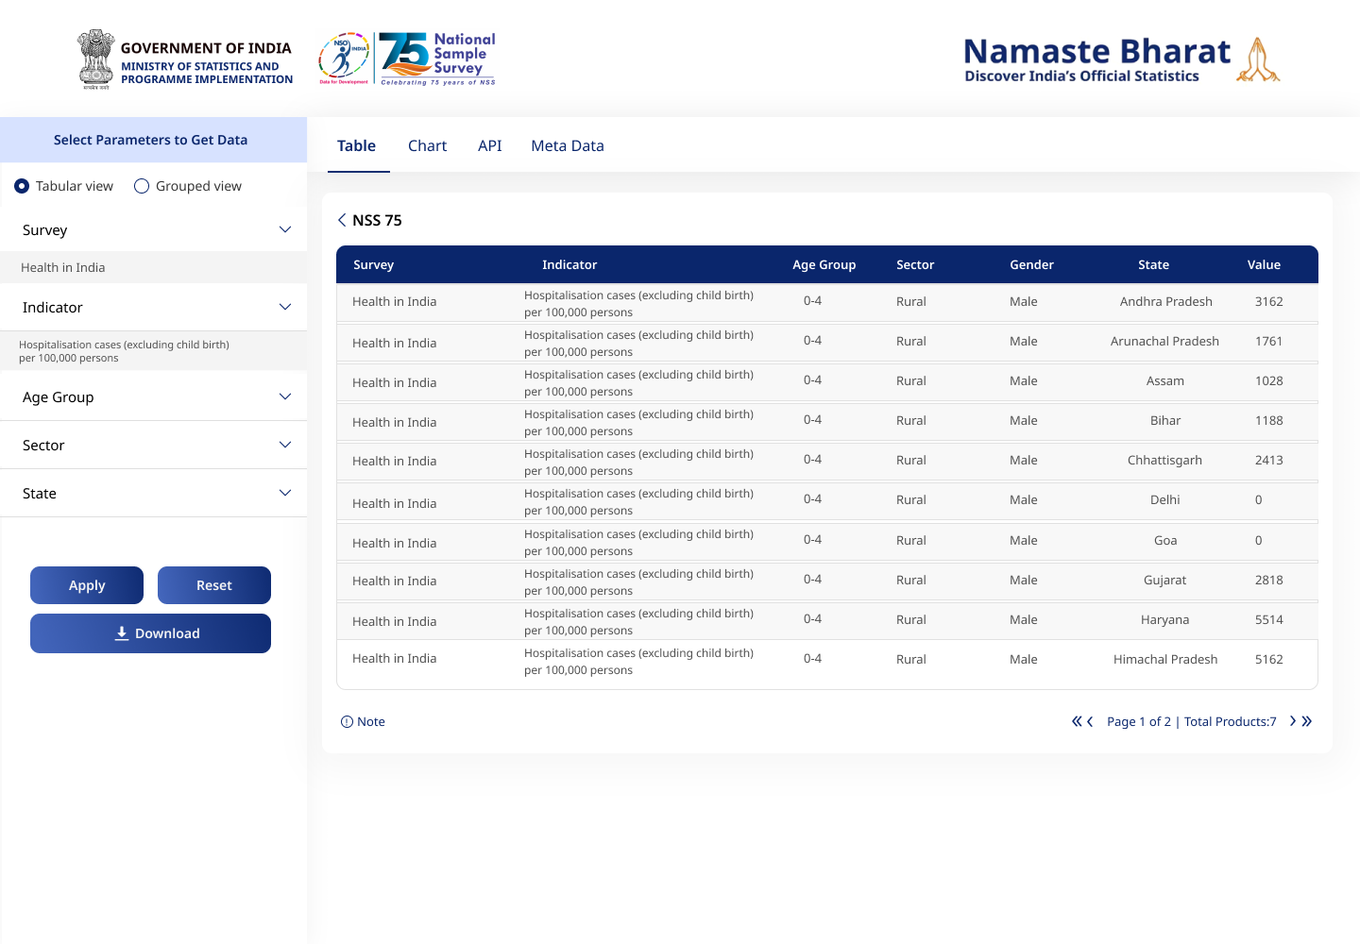
Figure 3: Data reflected in Tabular View of NSS 75th Round (Indicative)
- The details of filters provided for Health in India are given below:
Disaggregation Level | Filter Type | Description
Survey | Dropdown | Health and Education.
Indicator | Dropdown | List of Indicators to be shown. E.g. Hospitalisation cases (excluding childbirth) per 100,000 persons, Hospitalisation cases (excluding childbirth) per 100,000 persons etc. Refer to table no. 3.1.c for complete list of indicators.
State | Dropdown | The List of State/UT to select from check box
Sector | Dropdown | The list of Sector to select from the list (Rural, Urban, Rural+Urban)
Gender | Dropdown | The list of Gender to select from the list (Male, Female, Person)
Age Group | Dropdown | The list of Age Group to select from the list (0-4; 5-14; 15-29; 30-44; 45-59; 60-69; 70-74; 75-79; 80+; 70+; 60+; all)
- After applying respective filters user will click on Apply button to retrieve the relevant data according to filters selected by the user. User may use Reset option to reset the filter criteria as needed. User can Download the table in CSV format for further analysis.
- User can view 20 records on First page after that user can use navigation to see next 20 records. User can also see the last page records after clicking on the Last Page.
- A NOTE is provisioned below Table view at the left side corner along with symbol/ tooltip which reflects:
a) (*) Wherever appears in indicator/ value column denotes that one or more of parameter(s) for the selected filter(s) are not applicable for that indicator/value.
b) (-) Wherever appears in unit column denotes that values are absolute numbers with no specific unit of measurement.
c) Data for Usual Principal Status of Unemployment Rate is available from 2020-21 onwards.
- Also, user have the option to switch to the Grouped View presenting relevant statistical data with basic filters.
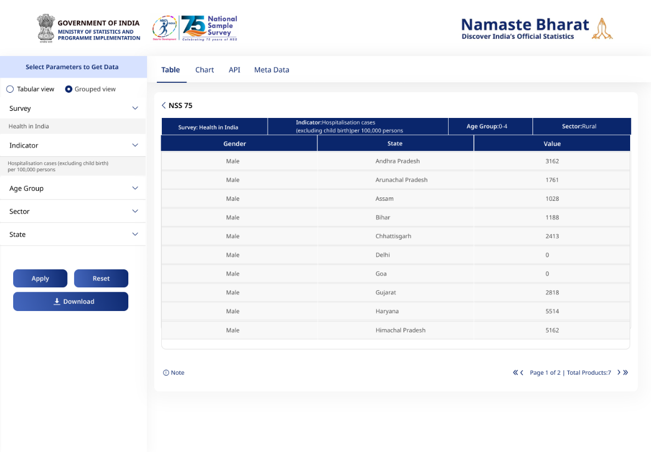
Figure 4: Data reflected in Grouped View (Indicative)
- Acceptance Criteria:
- Left-Side Filter Functionality
The system shall present the left-side filters in the following sequence and sorting order:
- Indicator: It will display as radio button (e.g., Hospitalisation cases (excluding childbirth) per 100,000 persons etc.) Refer to table no. 3.1.c for complete list of indicators.
- State: It will display in alphabetic order as Check Box for State/UT. (All India, Andaman & Nicobar Island, Andhra Pradesh…. West Bengal)
- Sector: It will display as Check Box (e.g., Rural, Urban, Rural + Urban).
- Gender: It will display as Check Box (e.g., Male, Female, Person, All)
- Age Group: It will display as Check Box (e.g., 0-4; 5-14; 15-29; 30-44; 45-59;
- Survey Name (Health in India/Education)

Chart
- The landing page of the NSS 75th Round product features four tabs (Table, Chart, API, and Metadata). The user clicks on Chart tab and it displays the default Bar Chart, presenting relevant data with various filters viz Indicator, Age-group, Sector etc.
- When the user lands on the page for the first time the default selection of filter details as given below:
- Indicator – Hospitalisation cases (excluding childbirth) per 100,000 persons
- State – All India/UT
- Age - group – 0-4; 5-14; 15-29; 30-44; 45-59; 60-69; 70-74; 75-79; 80+; 70+; 60+; all
- Sector – Rural + Urban
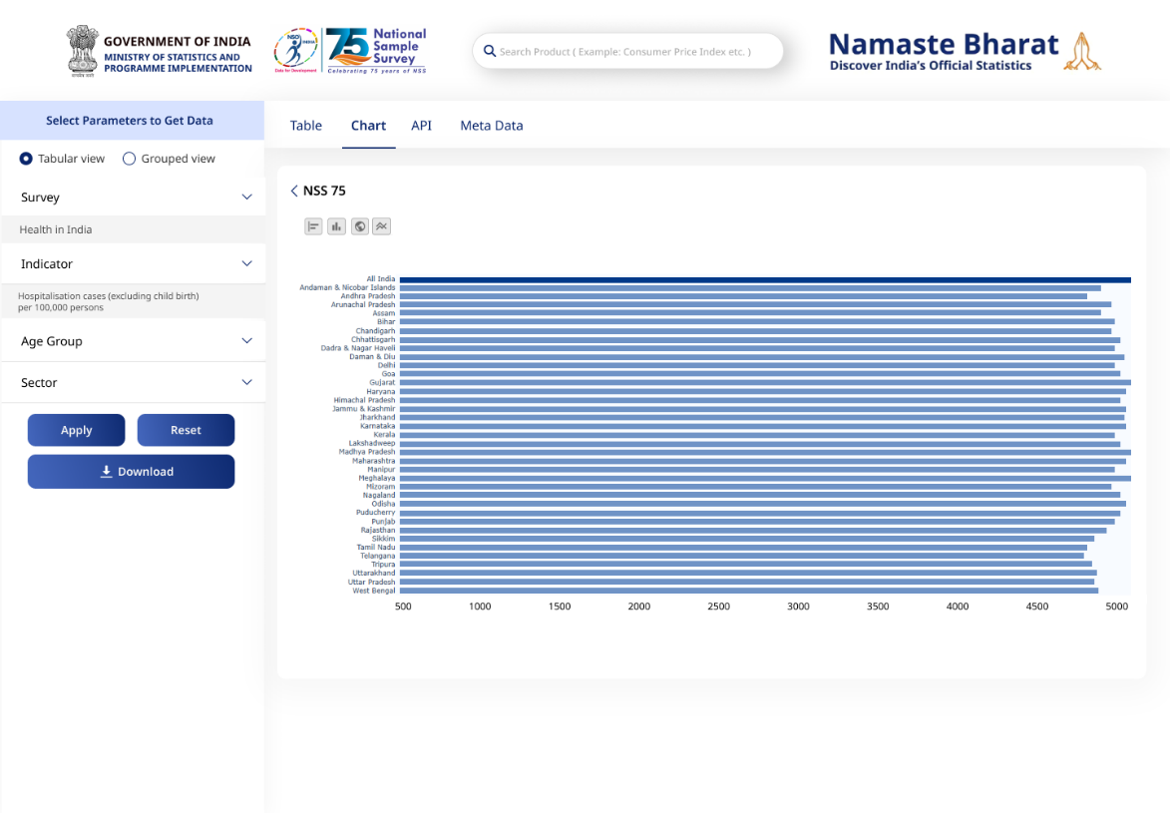
Figure 5: Data reflected in Bar Chart (Indicative)
- The indicator wise details in tabular form are given below for Health in India:
Disaggregation Level | Filter Type | Description
Survey | Drop Down | Health
Indicator | Drop Down | The Indicator used as Hospitalization cases (excluding childbirth) per 100,000 persons etc. Refer to table no. 3.1.c for complete list of indicators.
Age Group | Drop Down | Selection showing different Age-group as (0-80+ years, All Age etc.)
Sector | Drop Down | List of sectors as (Rural+Urban, Rural, Urban)
- After applying respective filters user will click on Apply button to retrieve the relevant chart. User may use Reset option to reset the filter criteria as needed. User can download the Chart in SVG format for further analysis.
- Acceptance Criteria:
- Left-Side Filter Functionality
The system shall present the left-side filters in the following sequence and sorting order:
- Survey: It will display a dropdown list as (health/Education)
- Indicator: It will display as dropdown list as (Hospitalisation cases (excluding childbirth) per 100,000 persons etc.)
- Age -group: It will display as dropdown (e.g. 0-4; 5-14; 15-29; 30-44; 45-59; 60-69; 70-74; 75-79; 80+; 70+; 60+; all).
- Sector: It will arrange as dropdown (e.g., Rural+Urban, Rural, Urban).
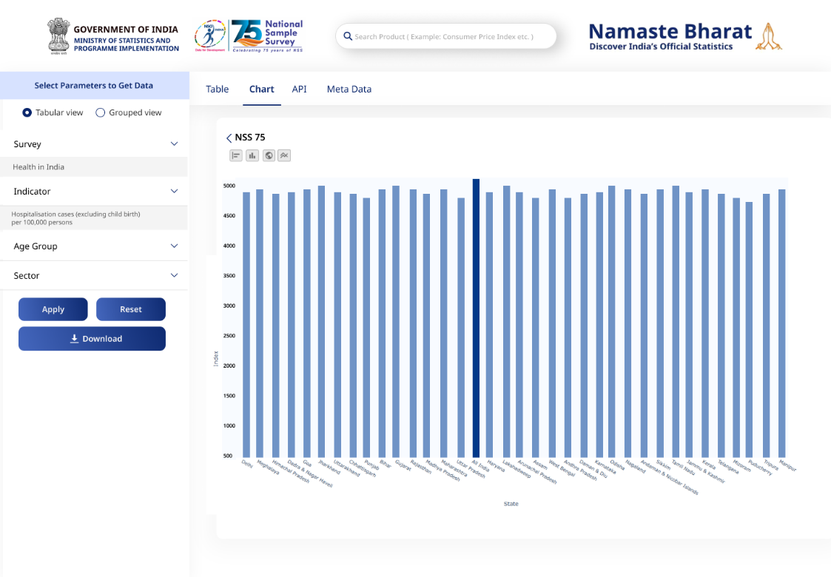
Figure 6: Data reflected in Bar Chart (Indicative)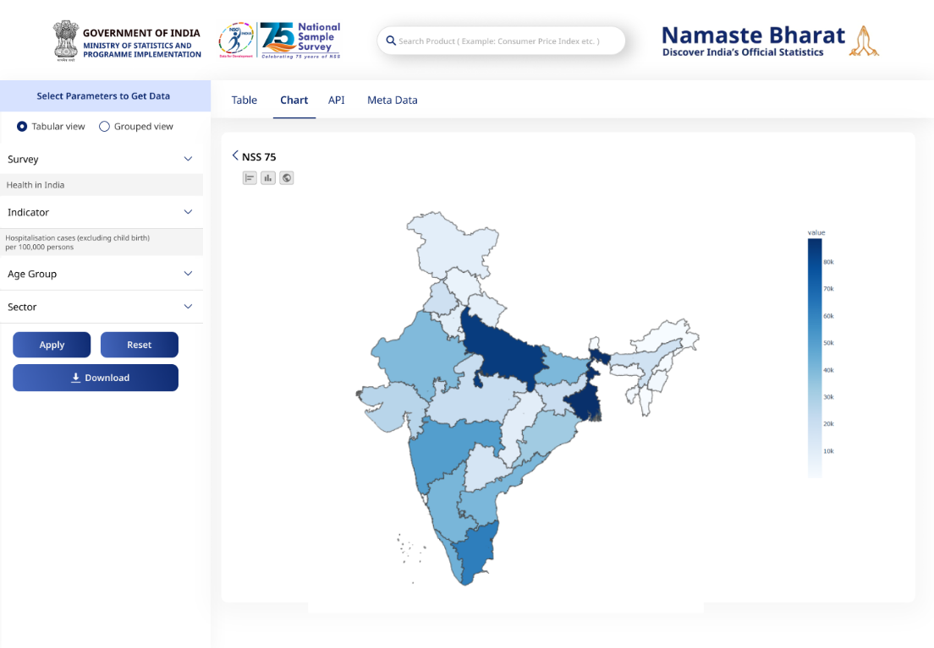
Figure 5: Data reflected in Map (Indicative)

API
- The landing page of the NSS product features four tabs (Table, Chart, API and Metadata). The user clicks on ‘API’ tab to display the API details as mentioned below:
- Open APIs available for NSS surveys. Indicator-wise NSS datasets.
- Metadata and User Manual should be available to facilitate API access and integration.
- To retrieve API data, the system will return only the first 10 records by default. For accessing the complete dataset related to the NSS 75th Round product, users must authenticate via the POSTMAN tool by obtaining an access token. The process involves:
- Postman Setup:
- Download Postman from Postman Website.
- Open Postman, sign in or use the “lightweight API Client.”
- Click the “+” button to add a request.
- Expand the method button.
- Base URL: https://api.mospi.gov.in
- User Signup:
- Use POST method with URL: Base URL/api/users/usersignup
- Select Body → Raw → JSON, and enter user details.
- Ensure a unique username and click Send.
- A success message confirms signup completion.
- Login Process: User generates Access Token via Postman
- Select POST, use URL: Base_URL/api/users/login.
- Select Body → Raw → JSON, enter login credentials (username, password).
- Click Send to receive an access token.
- Accessing NSS 75th Round Data through Postman: The following steps are involved while using Postman: (indicative example)
- Select GET, use URL: Base URL/ api/nss/getNSS75.
- Add Authorization Token in Headers (Key: Authorization, Value: Token).
- Click Send to fetch complete data.
Parameter Name | Data Type | Example
Survey | String | Option from Dropdown (1,2)
Indicator | String | Option from dropdown in API
Age Group_code | String | Format 1 to 12
Sector_code | String | Format 1 to 3
Gender_code | String | Format 1 to 3
- Results displayed in JSON/CSV format based on selected filters.
- Acceptance Criteria:
- Swagger UI serves as a visualization tool for API documentation and initially displays a preview of the first 10 records.
- Upon successful authentication, system shall respond with complete dataset pertaining to the filters provided.

Metadata
- Metadata is structured information that describes, explains, or gives context to data, making it easier to understand and analyze. Metadata facilitates interoperability and enhances transparency in data dissemination. It also supports analytical insights by providing details on data sources, which is a standardized framework developed by MoSPI.
- The landing page of the NSS 75th Round product features four tabs (Table, Chart, API and Metadata). When the user clicks on ‘Metadata’ the tab would display the Metadata details.

Non- Functional Requirement
This section provides the list of Non- Functional Requirements that should be considered while development of Dashboards, Visualization and APIs for onboarding NSS 75th Round to e-Sankhyiki. These requirements should ensure that the system meets performance, security, scalability, usability, and compliance standards.

Scalability & Load Handling
- The system must efficiently handle peak loads during high-traffic periods, supporting at least 40 to 50 concurrent users.
- A single user from one IP address should be limited to 10 hits per minute to ensure fair usage.
- The system should support horizontal and vertical scaling through cloud-native solutions like Docker.
- Database Optimization: Implement sharding and replication to handle large datasets effectively.
- The system should support scalable cloud-based or distributed database solutions for increasing data storage needs.

Performance Optimization & Testing
- The system must implement database optimization techniques such as caching and query optimization to enhance response times.
- APIs must be optimized to handle large-scale requests efficiently, with rate-limiting mechanisms to ensure fair usage.
- Support for asynchronous processing should be provided for data-intensive API calls.
- Response Time: The system must have a response time of ≤ 5 seconds on a 512 Kbps network, considering dataset volume.
- Throughput: Must support at least 40 to 50 concurrent users during peak load without degradation.
- Regular stress testing and performance benchmarking should be conducted to assess system limits and validate stability.

Reliability & Data Protection
- System Uptime: Maintain at least 99.9% uptime with minimal downtime.
- Backup: Ensure regular automated backups for data recovery in case of system failure.

Usability & Compliance
- The system must support all major browsers (Chrome, Firefox, Edge, Safari).
- Regulatory Compliance: Adhere to government regulations, including data protection and privacy laws.

Appendices

Glossary of Terms
Term | Definition
NSS | The National Sample Survey is a nationwide system of sample surveys conducted by the National Statistical Office under the Ministry of Statistics and Programme Implementation for the collection of socio-economic and demographic data on various aspects of the Indian economy and society using scientifically designed sampling methods.
Survey | A systematic collection of data from a sample of households or persons using structured schedules, conducted with the objective of producing statistical estimates for the population.
Household | A group of persons who normally live together and take their meals from a common kitchen, unless the exigencies of work prevent them from doing so
Sector | Classification of the place of residence of a household as rural or urban, based on Census of India definitions adopted for the National Sample Survey.
Rural Sector | Areas classified as villages in the latest Census of India and areas treated as rural for NSS sampling purposes.
Urban Sector | Areas classified as statutory towns, census towns, or urban agglomerations in the latest Census of India and adopted for NSS sampling purposes

Abbreviations
Acronym | Full Form
Acronym | Expanded Form
NSS | National Sample Survey
NSO | National Statistical Office
MoSPI | Ministry of Statistics and Programme Implementation
HH | Household
MPCE | Monthly Per Capita Consumption Expenditure
OOP | Out-of-Pocket (Expenditure)
ANC | Antenatal Care
PNC | Postnatal Care
PHC | Primary Health Centre
CHC | Community Health Centre
SC | Sub-Centre
NGO | Non-Governmental Organisation
SC/ST | Scheduled Caste / Scheduled Tribe
OBC | Other Backward Class
UT | Union Territory
BPL | Below Poverty Line

